Aircraft Documents

Minimum Equipment List

Explanation: Some aircraft contain a FAA approved Minimum Equipment List to allow them to operate with inoperative instruments and equipment. (UND aircraft contain these lists.)

Each list includes four components:
- Letter of Authorization
- Procedures Document
- Master Minimum Equipment List (MMEL)
- Preamble to the MMEL.

The Letter of Authorization (LOA) is issued by the FAA and lists the “N numbers” of all aircraft authorized to operate under the MEL. The Procedures Document explains which equipment may be inoperative for flight and what procedures/actions must be taken before the aircraft can be flown. The Master Minimum Equipment List is created by the aircraft manufacturer and lists all equipment that may be inoperative for flight. The owner/operator (UND) may choose to leave some of these items out of the Procedures Document, and which then must be operative for flight. The Preamble to the MMEL explains how the manufacturer created the MMEL.

Validity: The aircraft’s “N number” must appear on the LOA, and the FAA must approve the entire Procedures Document. The MEL (Procedures Document) + LOA = a Supplemental Type Certificate (STC) A STC allows an aircraft to be flown after it has been modified (i.e. a different engine, inoperative equipment, etc.)

Carriage: All four components of the MEL must be onboard the aircraft for flight. UND places them in a black binder, which is usually found on one of the rear seats.

Airworthiness Certificate

Explanation: The FAA issues an Airworthiness Certificate to all approved aircraft manufactured in the US (and some foreign countries).

Validity: The PIC must ensure that the Airworthiness Certificate is visibly displayed to all passengers and that the aircrafts’ “N number” appears on the certificate (Required per FAR 91.203). For the Airworthiness Certificate to be valid, all required inspections must be completed, all FAA Airworthiness Directives complied with, and the PIC must have found the aircraft safe for flight. The required inspections are explained in further detail in module two: Aircraft Maintenance. These inspections include either a 100 hour and/or annual inspection or a progressive inspection. Also, all equipment checks including ELT, transponder, and pitot-static inspections must be completed. The Airworthiness Certificate is transferred with the aircraft, except when it is sold to a foreign purchaser.

Carriage: The Airworthiness Certificate must be visibly displayed (for all passengers to see). When the aircraft is sold, the Airworthiness Certificate is automatically transferred to the new owner. UND aircraft display the Airworthiness Certificate on the aft baggage bulkhead

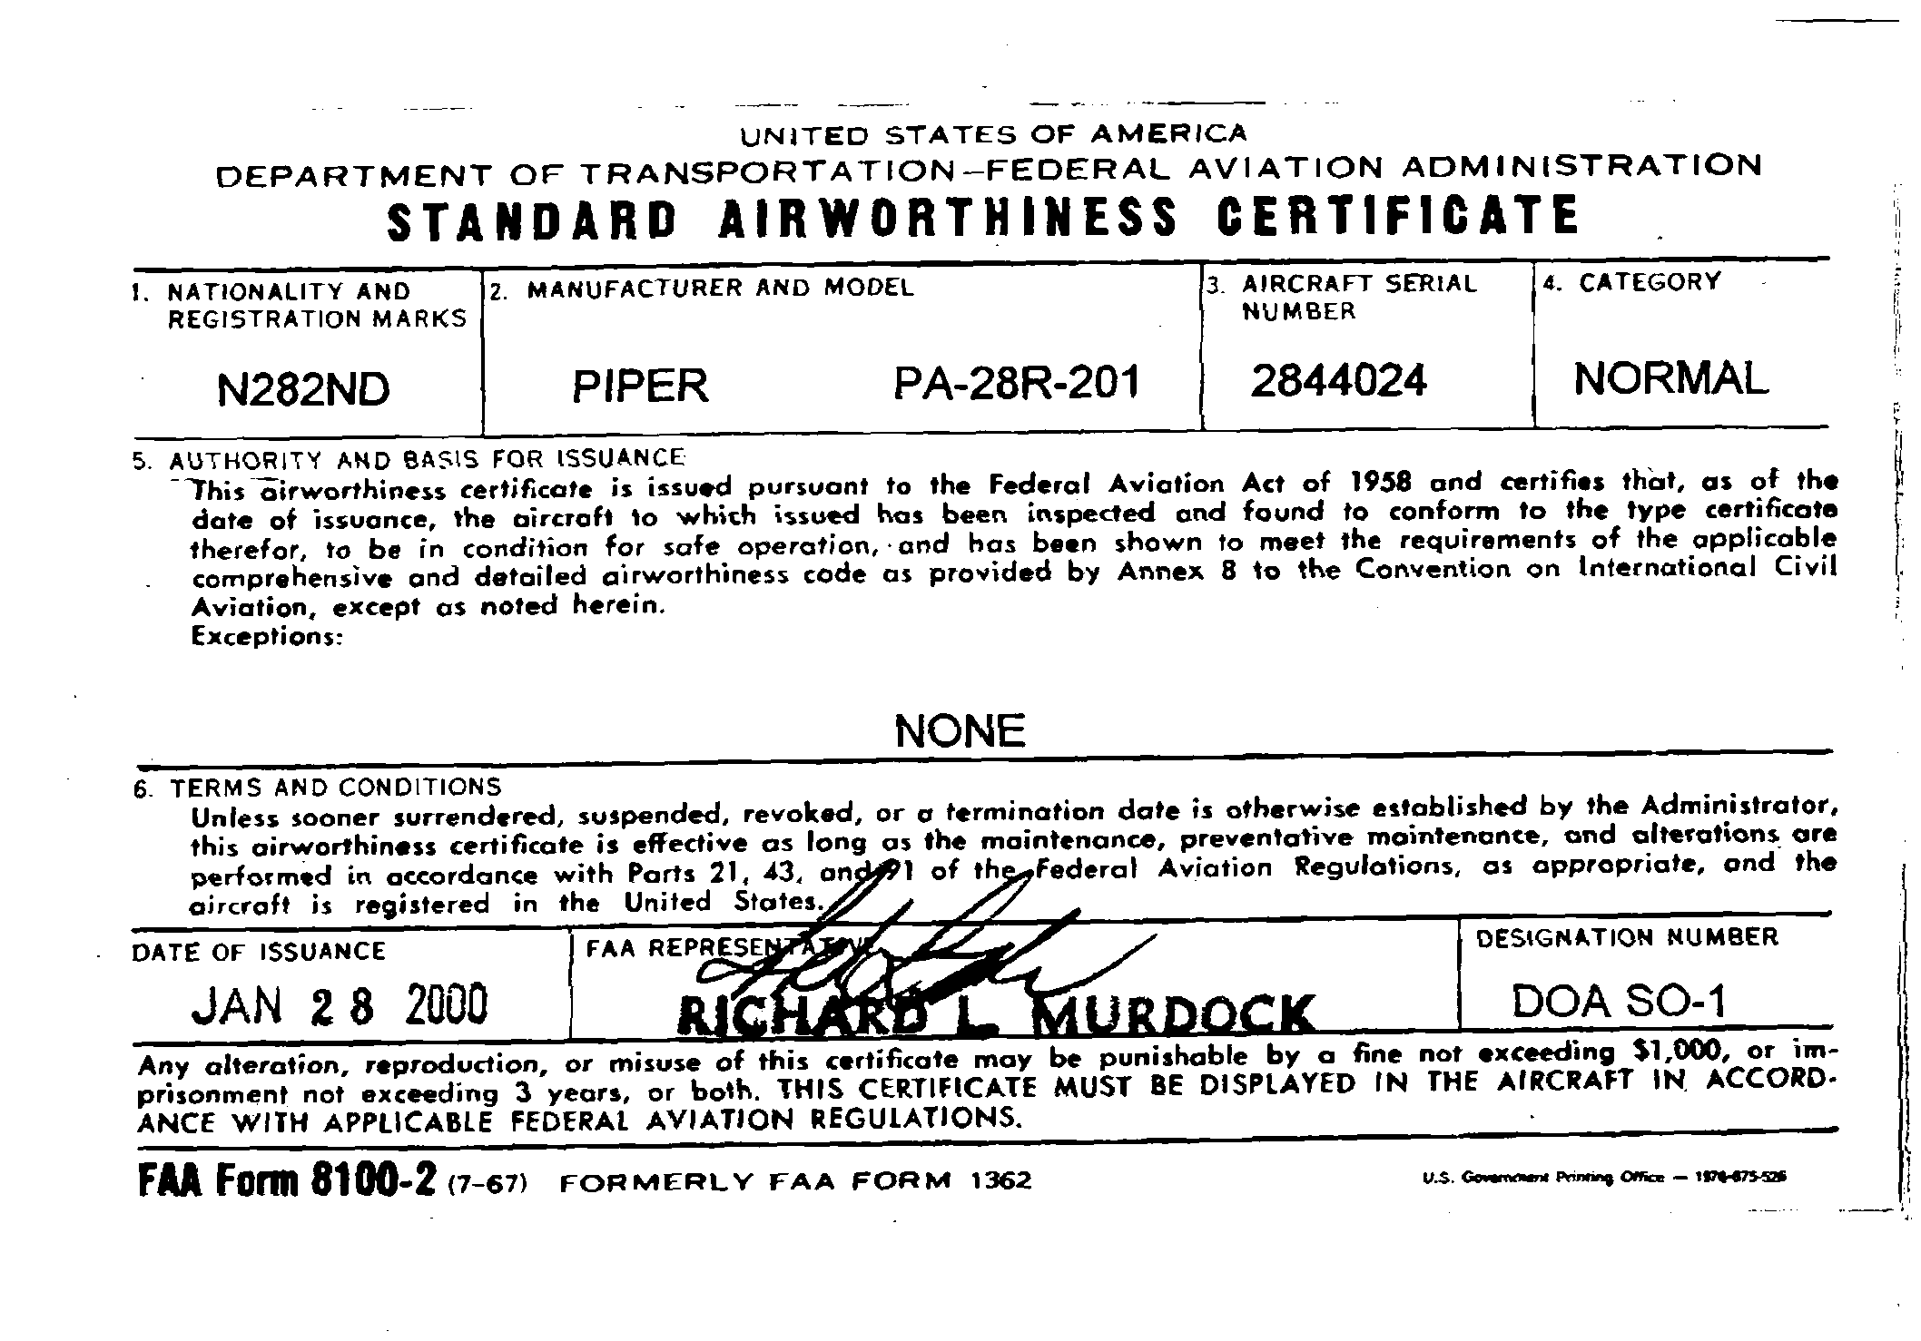
Federal Registration Certificate

Explanation: The FAA requires all US aircraft owners to register their aircraft. This registration is separate from any required state registration.

Carriage: The Federal Registration Certificate must be carried onboard the aircraft during flight. However, it doesn’t necessarily need to be displayed. UND displays the Federal Registration Certificate on the aft baggage bulkhead under the Airworthiness Certificate

Front Side of Federal Registration

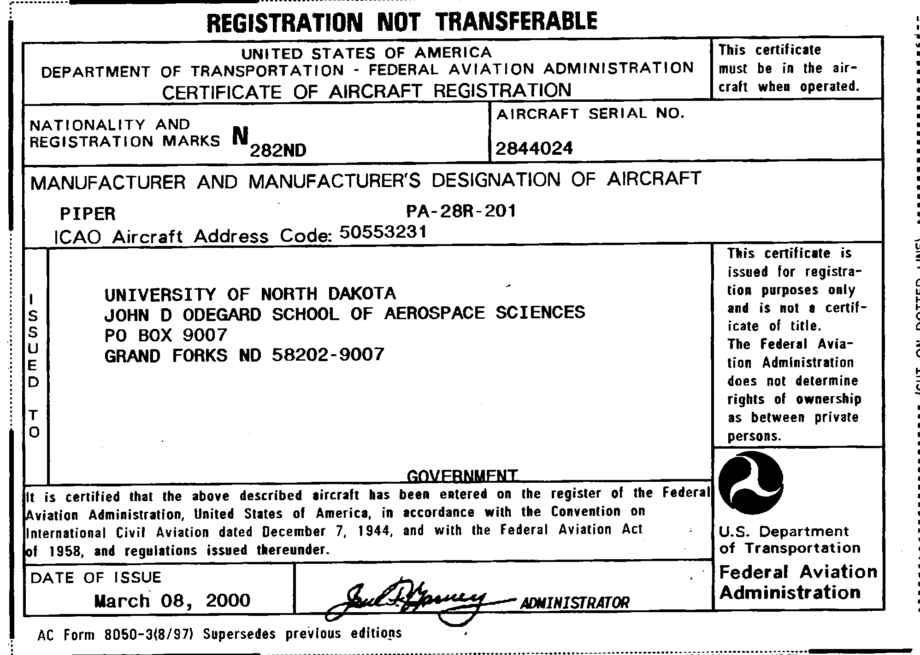
Rear Side of Federal Registration

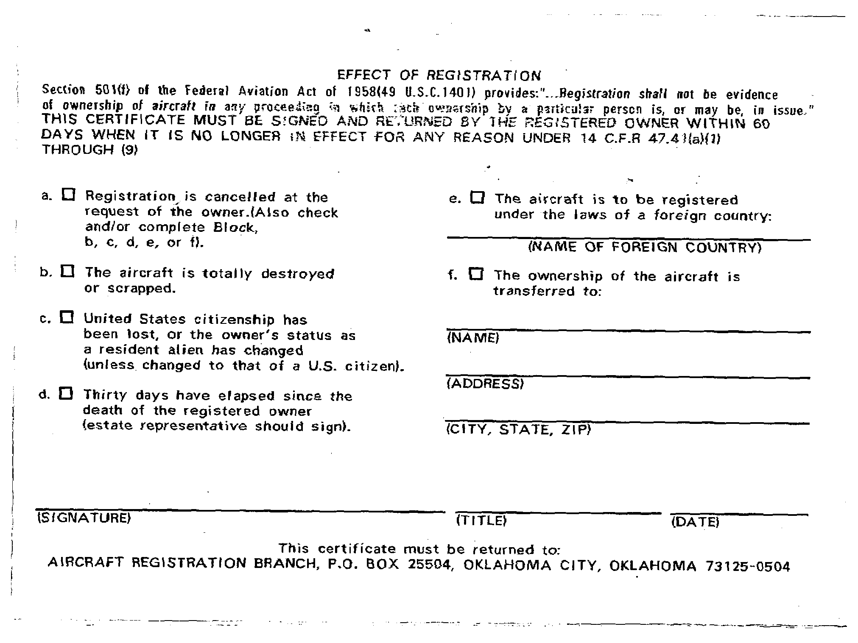

Validity: There are six ways the validity of the federal registration can come to an end. These can be seen on the rear side of the registration certificate.

- Registration is cancelled at the request of the owner
- The aircraft totally destroyed or scraped
- US citizenship is lost
- 30 days has elapsed since the death of the owner
- The aircraft is to be registered under the laws of a foreign country
- The ownership of the aircraft is transferred

State Registration Certificate

Explanation: Some states require owners to register their aircraft. (ND does require state registration.) Since the FAA does not require the certificate, it will generally not be examined during a FAA ramp check. If the owner does not register the aircraft (when required), the FAA will not take enforcement action (i.e. a violation) but the state may fine the owner/operator.

Validity: Each state will set there own requirements for validity. ND owners must register their aircraft annually, and the “N number” must appear on the certificate.

Carriage: UND aircraft carry the ND state registration in the back of the Dispatch Book. New aircraft may not have a ND Registration Certificate.

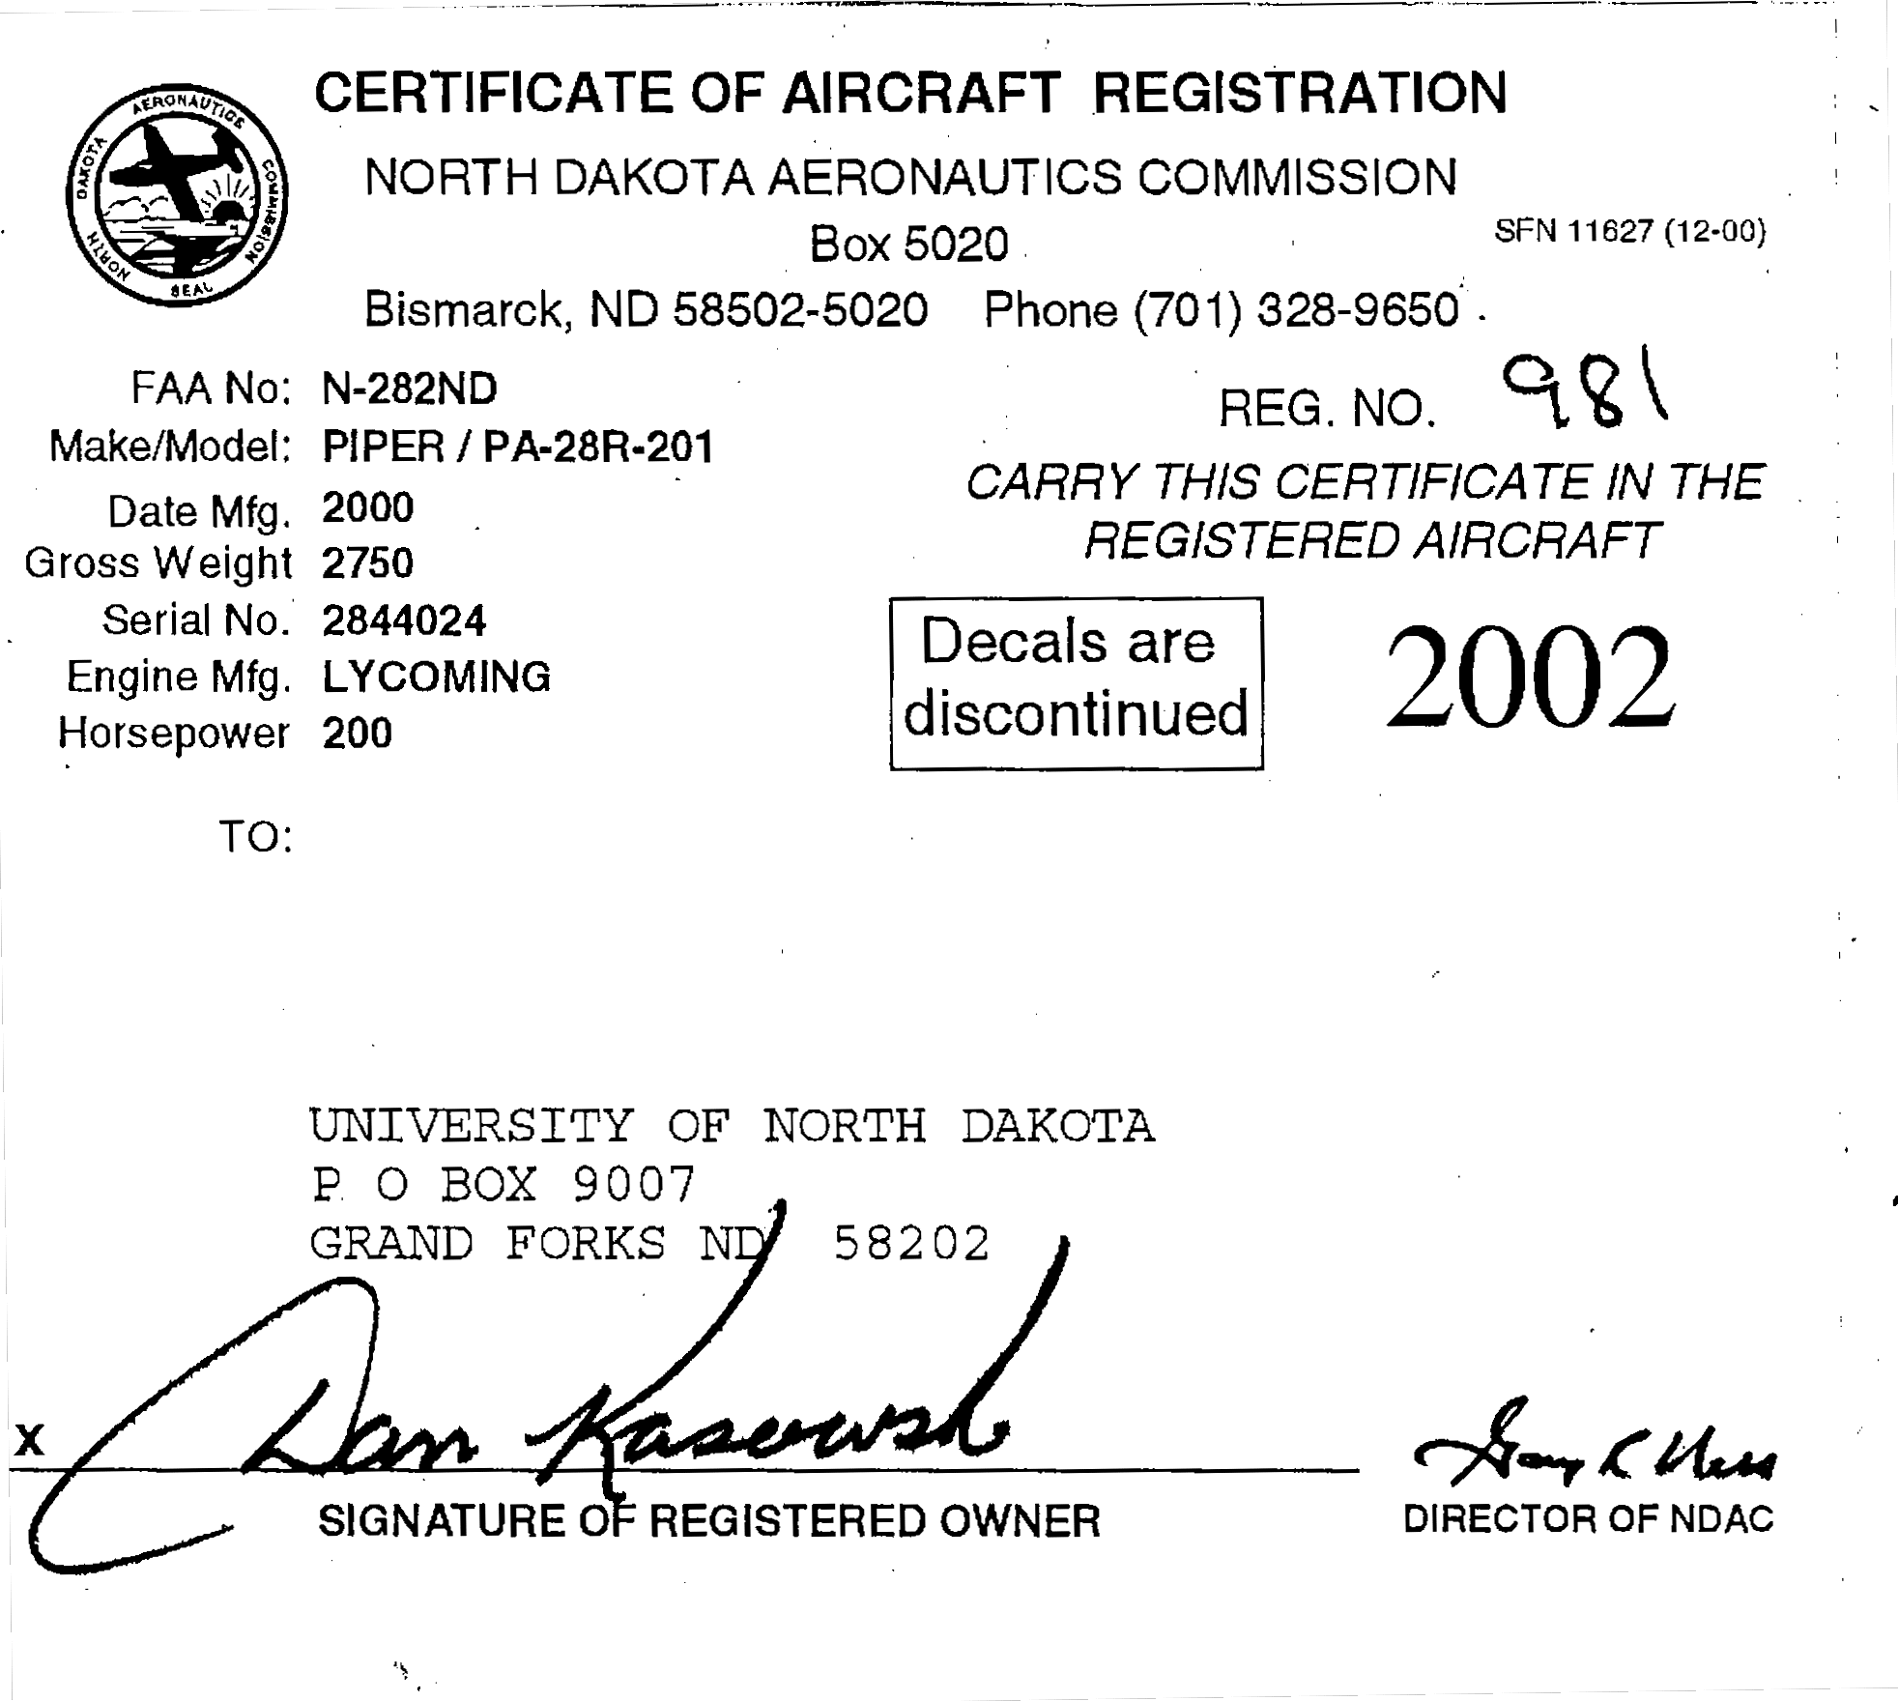

FCC Radio Station License

Explanation: US aircraft operated within the US are not required to carry a FCC (Federal Communications Commission) Radio Station License on board the aircraft. However, US aircraft operated outside of the US are required to carry a FCC Radio Station License on board.

Validity: The certificate must have the owners’ name and address, and display the aircrafts’ “N number.”

Carriage: The certificate is required to be carried on board the aircraft during flights into foreign airspace, but doesn’t necessarily need to be displayed. Five to ten aircraft are selected to carry the Radio Station License. You can identify these aircraft by the customs sticker displayed on the rear right side window. The Radio Station License should then be in the back of the Dispatch Book.

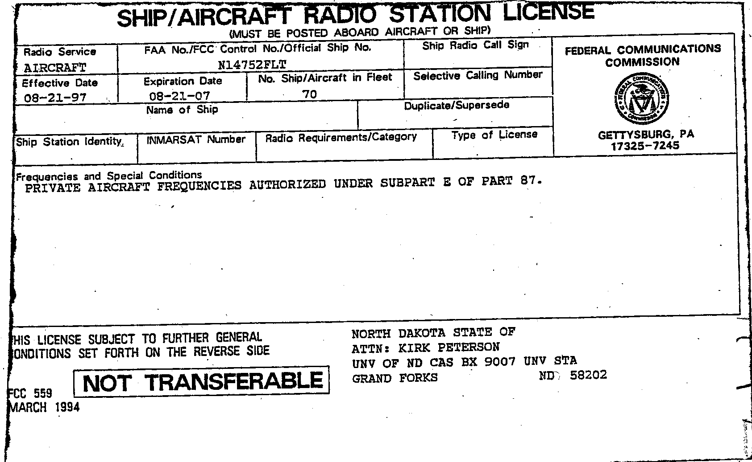

Pilots Operating Handbook

Explanation: All aircraft must carry the FAA approved Pilot’s Operating Handbook or Airplane Flight Manual. In addition, they must contain all placards required by the “Limitations” section of the POH/AFM. These are in accordance with FAR 91.9.

Validity: The POH must display the aircrafts’ “N number” and serial number on the cover page and is required to be on board the aircraft. POH’s purchased in the UND bookstore or from other pilot shops are not considered official. This is because any changes in the POH are only reflected in the POH for that particular aircraft.

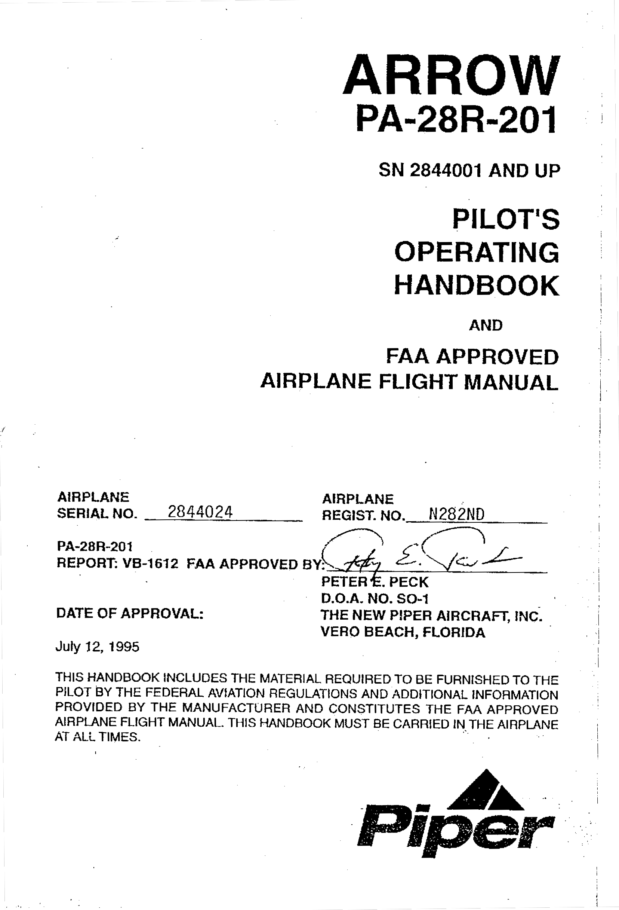

Carriage: The POH/AFM and all required placards must be on board the aircraft during flight. UND carries the POH in the seat pocket behind the pilot or copilot seat.

Weight and Balance

Explanation: Each aircraft must carry a record of the current basic empty weight, moment, and useful load.

Validity: The weight, moment, and useful load must be published by the factory or approved (signed) by a certified mechanic. (i.e. A&P, CRS)

Carriage: The weight and balance is found in Section 6 of the POH, and the original equipment list is found in the back of the approved POH. When the weight and balance/equipment list is revised (i.e. due to the addition of new equipment), the old weight and balance is labeled “Superceded DD/MM/YY.” The new weight and balance and equipment list revision form is filed in Section 6 of the POH

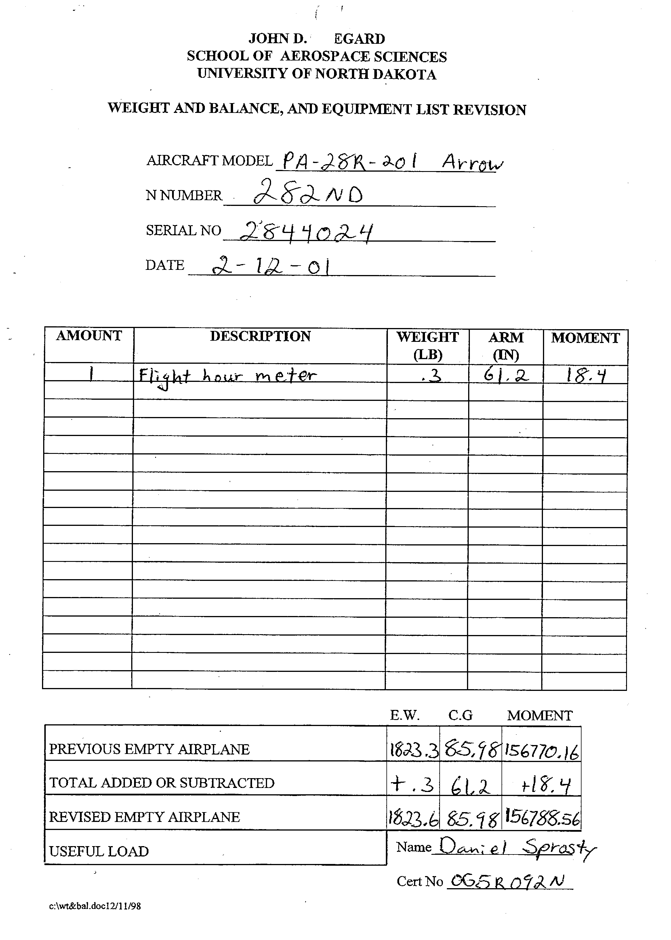

VOR Equipment Check Log

Explanation: No person may operate an aircraft under IFR using the VOR system of radio navigation unless the VOR equipment has been checked within the preceding 30 days.(FAR 91.171) Additionally, it must have been found to be within the limits of the allowable bearing error. Bearing allowances are +/- 4º for VOT checks, +/- 4º for surface VOR system checkpoints, +/- 6º for airborne VOR system checkpoints, and within 4º for dual VOR checks. Each entry in the log must include the date, place, bearing error, and be signed.

Validity: The log never expires but the last entry must be with within the preceding 30 days if VOR equipment is to be used under IFR.

Carriage: UND carries the log in the back of the aircraft dispatch book.

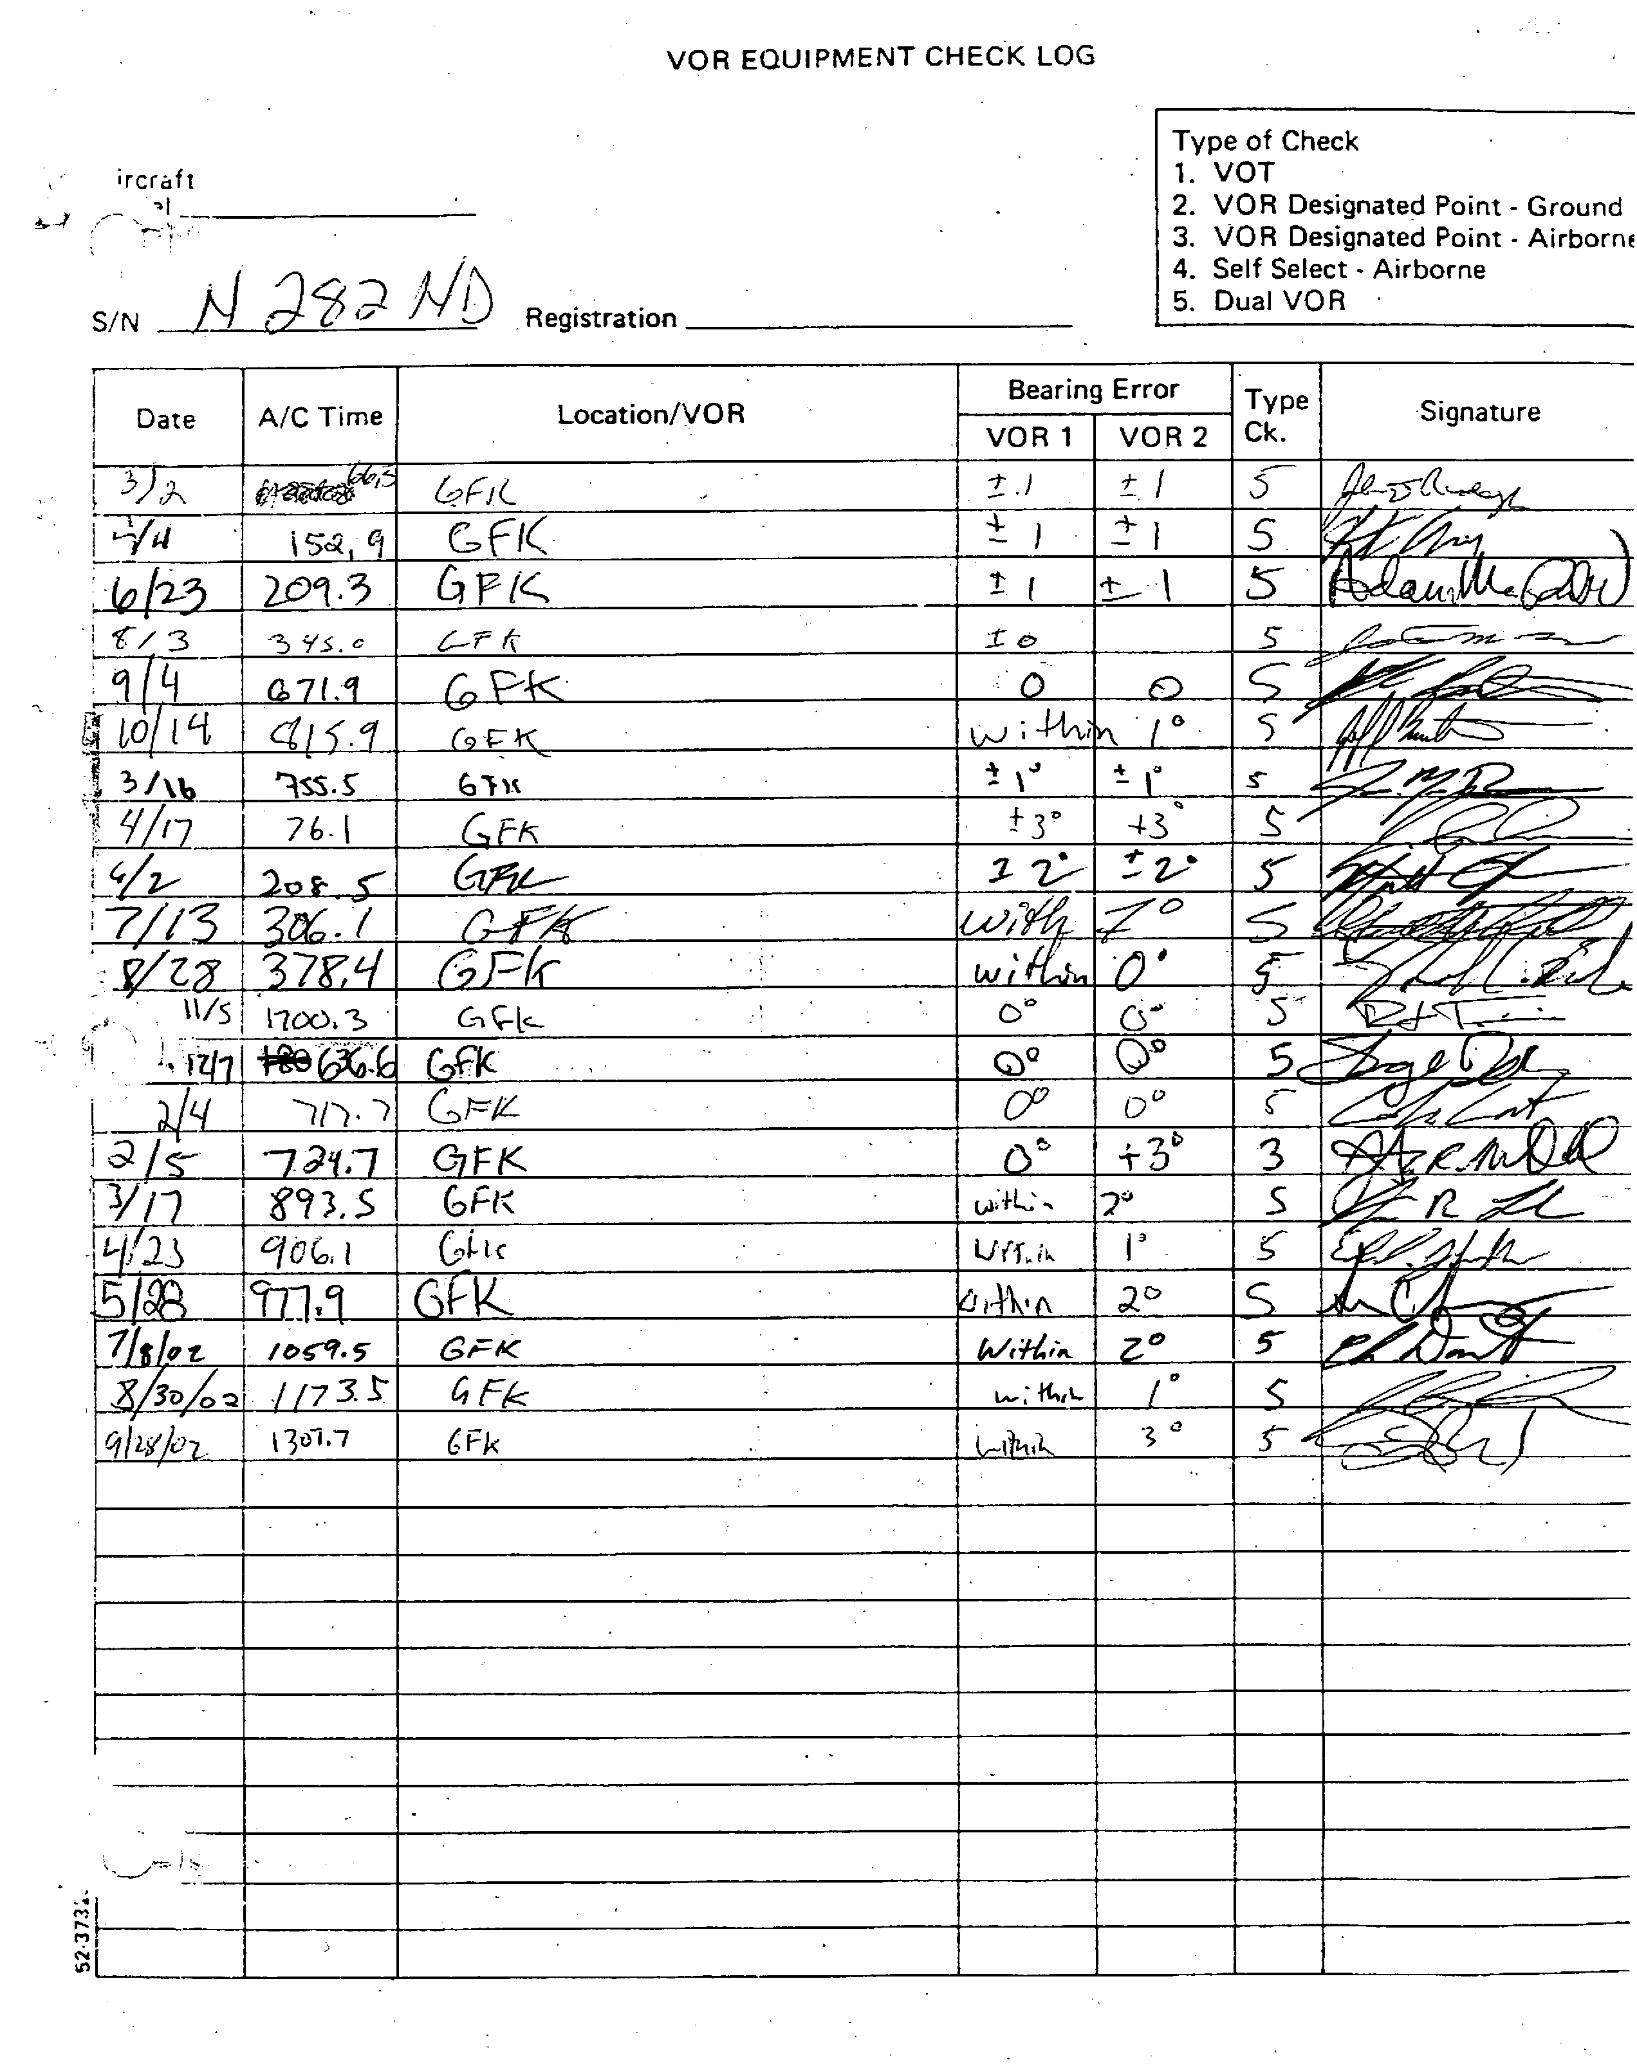

Magnetic Compass Correction Card

Explanation: Each aircraft must have a placard that shows the deviation with the engines operating. The requirements are found in FAR 23.1547

Validity: The magnetic compass should be swung and a new correction made up when first installed, any time equipment is added or removed and any time the pilot suspects compass accuracy. Each calibration reading must be in terms of magnetic headings in not more than 30º increments.

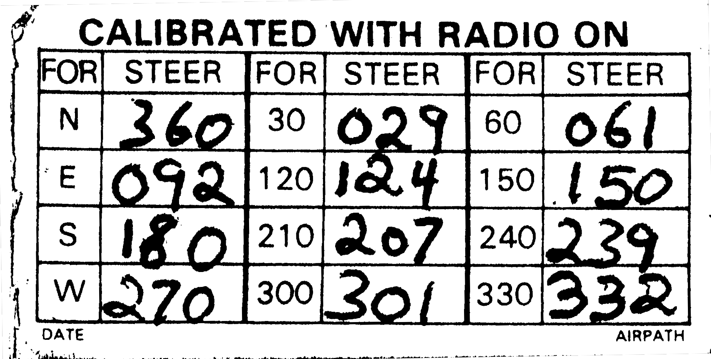

Carriage: Be visible to pilots in flight

Aircraft Equipment List

Explanation: The aircraft must carry a list of all equipment, standard and optional, installed on the aircraft

Validity: The equipment list must be up to date and complete

Carriage: The original equipment list is found in the back of the approved POH. When the weight and balance/equipment list is revised (i.e. due to the addition of new equipment), the old weight and balance is labeled “Superceded DD/MM/YY.” The new weight and balance and equipment list revision form is filed in Section 6 of the POH



